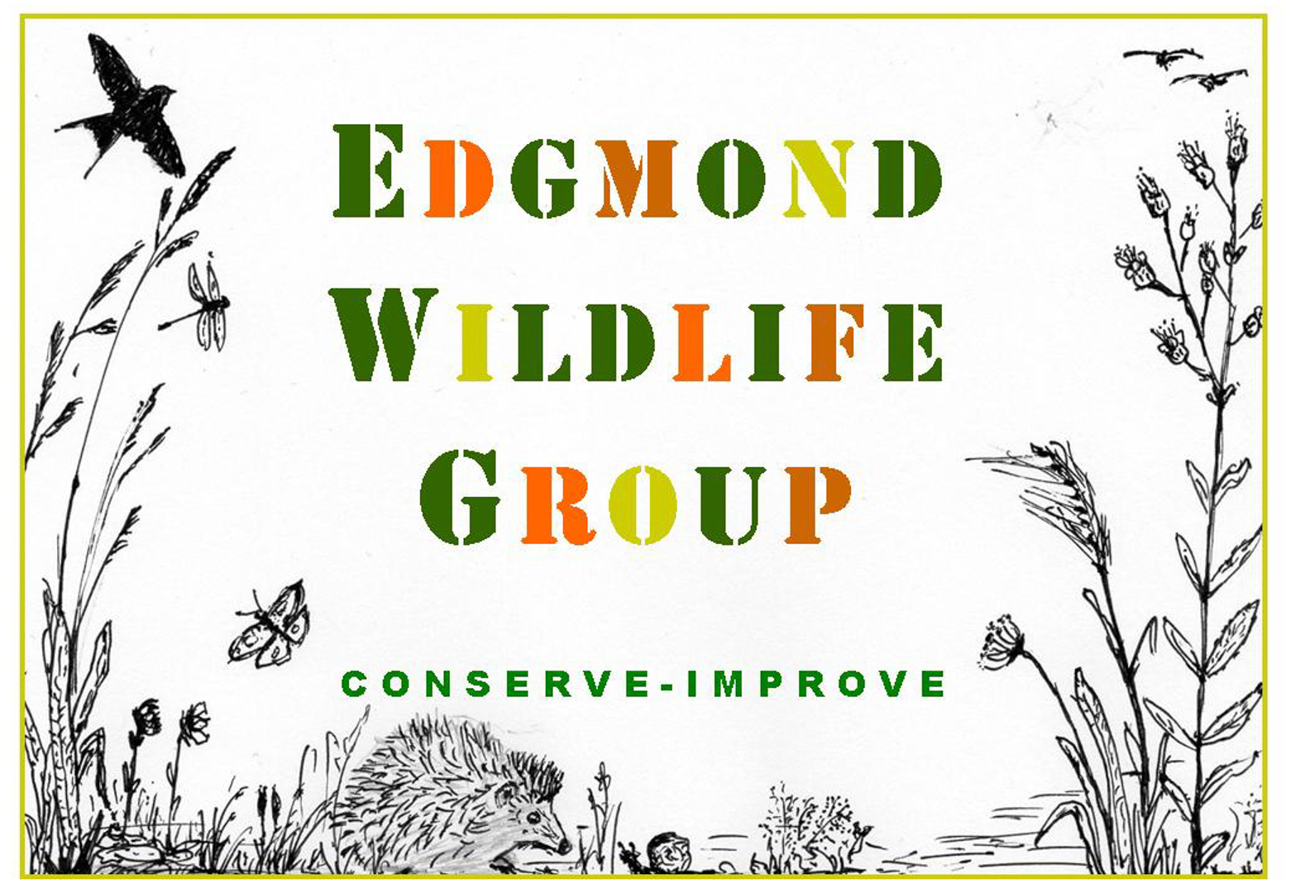
EDGMOND WILDLIFE GROUP
INFORMATION & MEMBERSHIP FORM
NAME:  ADDRESS &  POSTCODE:  EMAIL:  LANDLINE PHONE:  MOBILE PHONE: | Family Membership is for one or more adults with one or more children living at the same address. Please enter the name and email address of the family member who will be the primary point of contact.  Our membership year begins on June 1st. If you join between Jan and May, your membership payment will cover those months as a bonus. If you join between June and Dec your annual membership will still begin on June 1st.  Thank you for your support!
Details of events, activities, and news updates, are sent by email. All personal information will be held in accordance with current data protection guidelines.

You can find out more about us on our web site and Facebook pages:
Website: www.edgmondwildlife.com
Facebook: edgmond wildlife group
You can also join our local Nextdoor group.

WHO ARE WE? The Edgmond Wildlife Group (EWG) was formed in the Spring of 2020. A Group of residents came together to share their concerns about the environment and to do something locally. The common thread running through the Group is a desire to work with local people to improve our local environment for wildlife and people.

WHAT DO WE DO? We are a ‘hands-on’ Group. We take on practical conservation projects in our local area. We want to inspire others to learn more about our wildlife and the environment and to demonstrate that even small changes can make a big difference.

WHAT DO WE BELIEVE IN? By joining together, we can achieve great things. If we make small improvements in our gardens, green spaces, and the wider countryside this will help to support an environment rich in wildlife.

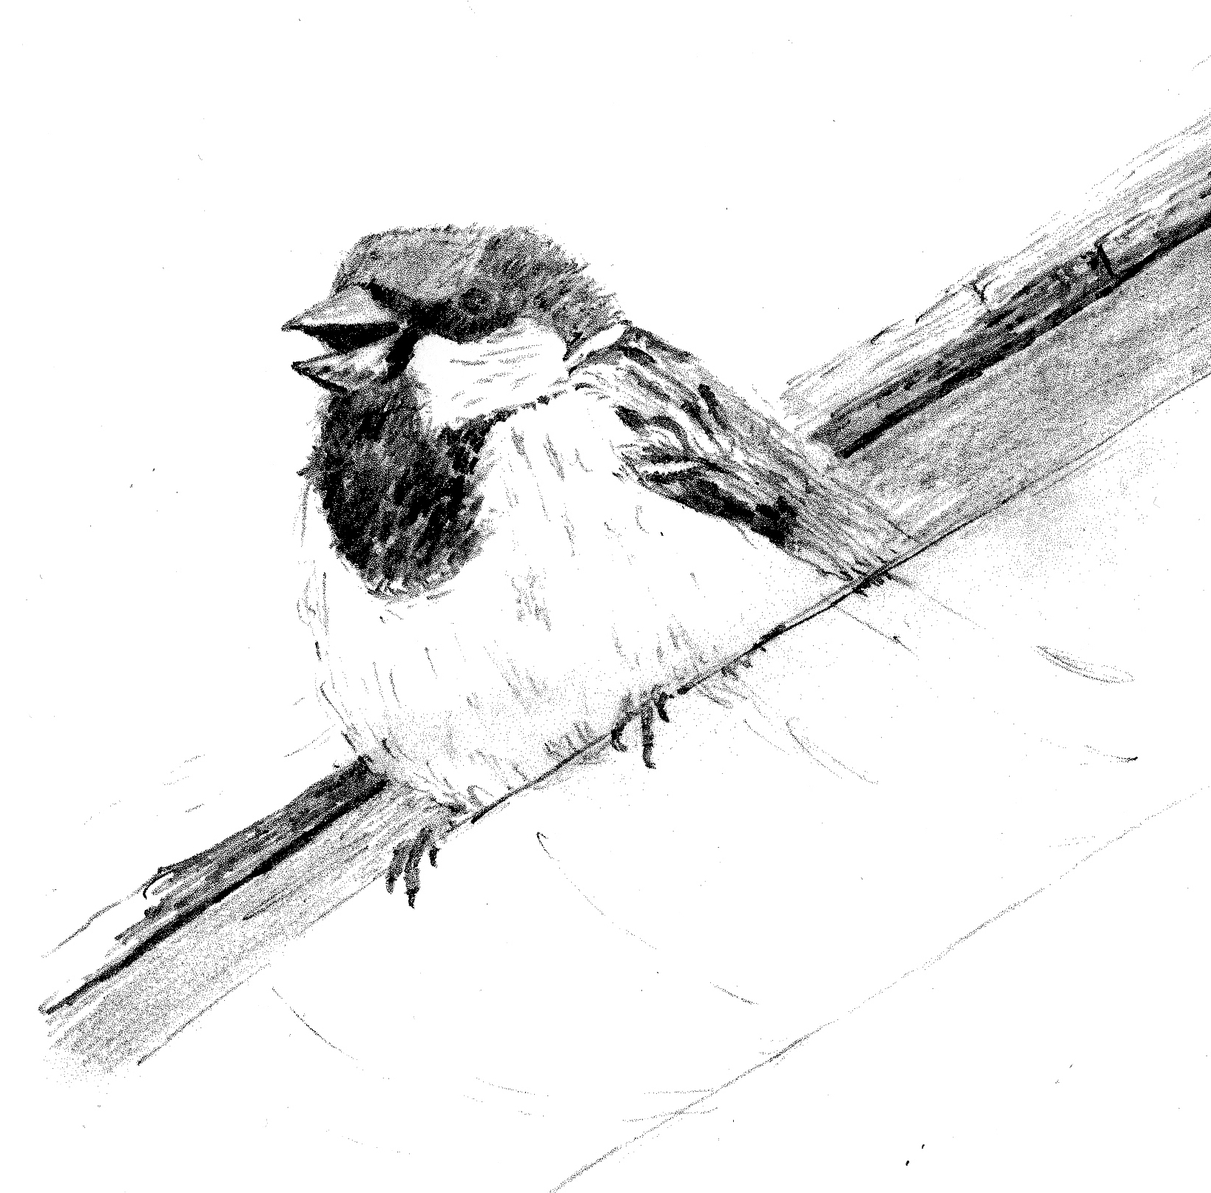
WHY JOIN US? Everyone benefits from a healthy green environment, rich in wildlife. If you join us, you will be supporting our work to improve local biodiversity by developing a greater variety of habitats in and around the parish. You can join us on guided local walks and share the pleasure in knowing that you are helping to maintain local wildlife for now and the future.
ANNUAL MEMBERSHIP
Please circle your membership type and what method of payment you are using:

Single Adult: £8
Family: £10
Student: £4

CASH CHEQUE or BACS bank transfer.

A STANDING ORDER is the best way to ensure continuing support!

AMOUNT PAID:

For bank transfers and Standing Orders use your surname as a reference.
Lloyds Bank 23648460 30-99-50

RETURN by post, hand, or email to our TREASURER Michelle: 15-17 School Road, Edgmond, TF10 8LB Michellewilson25@hotmail.com. If you have any queries, please contact Michelle on 07878 987823

